**Adapted from Dr. Heather Feaga Spring 2023 class. Annotated by Brandon Reyes-Chavez Oct. 2023**

ChimeraX user guide: **https://www.cgl.ucsf.edu/chimerax/docs/user/index.html**

Download link: **https://www.cgl.ucsf.edu/chimerax/download.html**

Files ChimeraX takes: **https://www.cgl.ucsf.edu/chimera/docs/UsersGuide/filetypes.html**

**PART I – How to FIND structures**

- Protein structures have a 4-digit code associated with them (PDB number) or uniprot number that can be used to find a PDB file associated with them.

- If this protein is not published in any database, you may run your protein sequence through Phyre2 (my personal fav) or Alphafold to get a PDB file, this may take a couple hours.

-You can also run Alphafold in ChimeraX with:

Tools > structure prediction > Alphafold > click sequence dropdown menu > click Paste > paste amino acid sequence > click predict. This will pull up a google page that will run Alphafold predictions with ColabFold. You need a Google account, it’s free to run the alphafold but you only get 2 hours on the server per day. *check end of handout for more info on running this.

1. Go to [www.rcsb.org](http://www.rcsb.org) to search for solved protein structures and get their PDB File.
2. Type in a protein you want to look for, for example elongation factor P
3. On the left-hand side you can choose a species
4. Check *Pseudomonas aeruginosa* and then press the blue button with the bright green arrow

1. A close-up of a document

   Description automatically generatedYou can search directly on the site, or get PDB numbers from publications:
2. A screenshot of a computer

   Description automatically generatedClick Download Files dropdown and download PDB format file.

**Part II – How to LOAD structures and re-color**

1. Download/Open ChimeraX and drag and drop PDB file into ChimeraX window.
2. Click black background + shift to move protein position without rotating
   1. Click protein and drag to rotate. Pinching trackpad will zoom out and opposite will zoom in.
   2. To center protein in the middle of screen, click on protein in models section and click view. If this section is ever closed by accident, you can re-access it under: Tools > Models. Same can be said for other interfaces that are open, like the log.

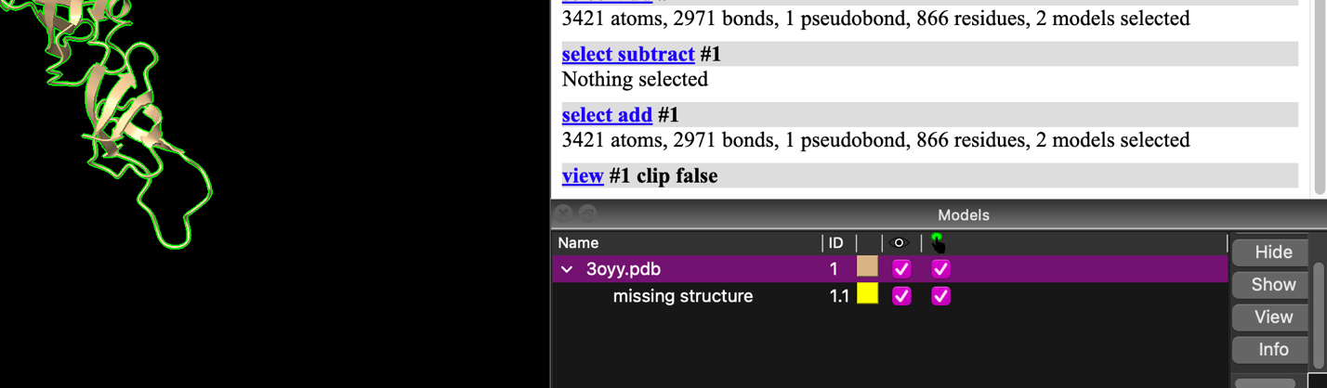

1. **View protein sequence by:**
   1. go to Tools 🡪 sequence 🡪 Show sequence viewer 🡪 OK
2. Where it says background, you may select a white or black background
3. A screenshot of a computer

   Description automatically generatedChange color of structure by clicking colored box in “Models” section to color that pops under background of choice
4. Blue highlights in the sequence are beta strands, yellow are alpha helices, residues in a black box are not resolved
5. Change the color of the ribbon structure by clicking section of choice (blue/yellow bits) 🡪 going to actions 🡪 color 🡪 then pick a color

**Many ways to make selections:**

* Hold the control key and select the residue you want
* Highlight the residues from the sequence panel
* To highlight an entire chain go to Select 🡪 chains 🡪 choose a chain to select
* To expand a selection (such as go from a residue to a loop that residue is a part of) press the up arrow

**To invert a selection (select everything except a particular chain):**

Once the chain is selected go to Select 🡪 Invert

**To clear a selection:**

Press ctrl + click anywhere outside the selection

**To color a selection:**

With the specific residue, loop, chain, etc. selected go to Actions 🡪 Color 🡪 pick different color, the color will only be applied to your selection

Actions 🡪 color by element

Heteroatoms are atoms other than carbon

Nitrogen are colored blue, and oxygens red, sulfurs yellow

**Part III ­– surface filling model of protein, electrostatics, and hydrophobicity**

1. Go to **Molecule Display** and then press **Chain** to view the different chains in the protein
2. Next, select Graphics and play around with some of the lighting and effects
3. The side view tool can slice the object to reveal internal features
4. **Molecule Display** and then press **electrostatic** (positive charges will be modeled in blue and negative charges modeled in red)
5. **Molecule Display** and then press **hydrophobic** (hydrophobic regions will be modeled in yellow and hydrophilic in green)

**Find information about your protein**

Click your protein in the models window 🡪 Click info

If your protein is a characterized protein with a uniprot ID you can see features of your protein by 🡪 clicking link under UniProt region that is in the log. Click features of choice, the corresponding region in amino acid sequence will be highlighted in the sequence viewer.

**Part IV Run Protein Blast of protein.**

Click Tools 🡪 Sequence 🡪 Blast Protein

**Matrix**: amino acid substitution matrix to use for alignment scoring.

**Cutoff**: this corresponds to the E-value which allows for increased confidence in comparisons

**Sequences**: Number of hits it will show.

**Query**: amino acid sequence with which to search the database, which is usually just opened protein so you can keep as “No chain chosen”

**Database**: Protein database to search in.

Clicking Apply (or OK, which also dismisses the dialog) runs the search, whereas Close dismisses the dialog without starting a search. Will take a couple seconds or minutes and will open Blast result window. 🡪 Click Species and any other features you want to be added to the results. 🡪 click “Show Sequence Alignment” at bottom of window to show conserved regions between proteins. 🡪 if interested in a particular protein click “load structures”

**Compare similarity between loaded structures from Blast result, or any loaded protein**

Tools 🡪 Structure Analysis 🡪 MatchMaker, this should superimpose your proteins to fit in the closest match possible.

If window pops up, click “alignment” section 🡪 Check “show pairwise sequence alignment” 🡪 click OK

This will pull up the MatchMaker Alignment window and the red boxes are the residues that are aligned. The Root mean square deviation (RMSD) will show how deviated the residues are in the protein.

Show only aligned regions of protein: Click red box in sequence view 🡪 This should highlight all the other red boxes (aligned residues) 🡪 click “Select” 🡪 Invert 🡪 this should select all the non-aligned regions of the sequence 🡪 Click hide in Cartoons and Atoms section 🡪 All that is shown should be the aligned part of the proteins.

If you want to move the individual proteins apart 🡪 Click “Right mouse” Section 🡪 Click “Drag model” 🡪 either right, click with mouse or use two fingers to click one of the proteins to drag and move it around.

**Part V Save images from ChimeraX**

File 🡪 save… 🡪 save to preferred file type, I’d recommend clicking “transparent Background” but if you prefer black or white background keep this box unchecked. Again you can change background color under “Home” section and in the “Background” section of this.

**Create a spinning video of protein.**

Under “home” section 🡪 under images click “Spin Movie” 🡪 Will automatically start spinning and when done will automatically download MP4 file.

**\* Run Alphafold in ChimeraX**

1. Tools 🡪 structure prediction 🡪 alphafold
2. A tool bar shows up on the right
3. Paste the amino acid sequence
4. Click Predict
5. It will ask you to sign into Google
6. It will give you a warning that the code is not from Google, run anyway
7. It will take about 1 hour to do a 100 amino acid sequence
8. At the very bottom a green check will appear when finished
9. When complete the structure will automatically load into the open ChimeraX window